**Bài tập CSDL buổi 3**

**Tạo CSDL bán hàng như sau: Lưu ý tên cột và tên bảng không bỏ dấu tiếng Việt.**

**SANPHAM(MaSP, TenSP, DVT): MaSP là khóa chính, tenSP va DVT not null**

**(thay cột STT thành MaSP và nhập các giá trị là SP01..SP20)**

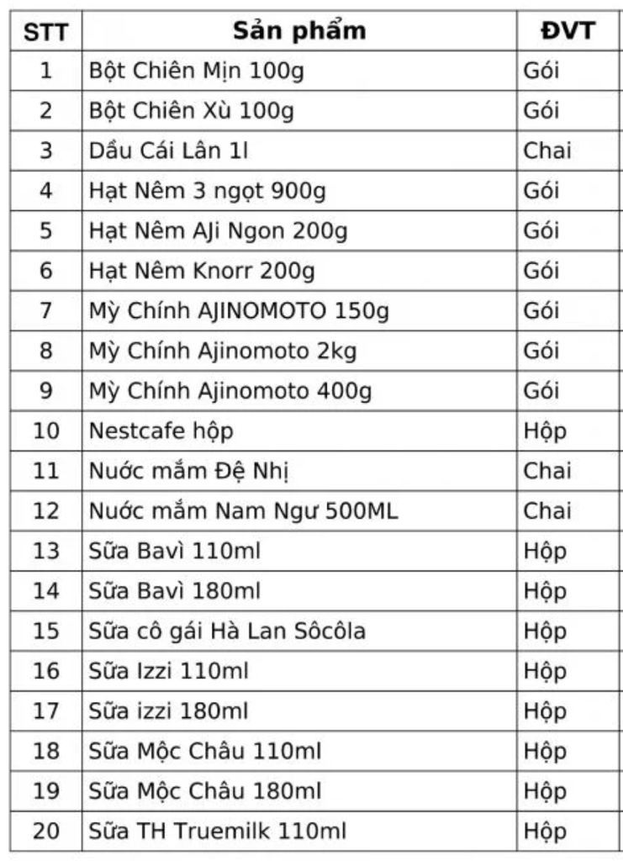

create table  SANPHAM(

MaSP char(4) primary key,

TenSP varchar2(60) not null,

DVT varchar2(30) not null

);

INSERT INTO sanpham VALUES ('SP01', 'Bot Chien Min 100g', 'Goi');

INSERT INTO sanpham VALUES ('SP02', 'Bot Chien Xu 100g', 'Goi');

INSERT INTO sanpham VALUES ('SP03', 'Dau Cai Lan 11', 'Chai');

INSERT INTO sanpham VALUES ('SP04', 'Hat Nem 3 ngot 900g', 'Goi');

INSERT INTO sanpham VALUES ('SP05', 'Hat Nem AJi Ngon 200g', 'Goi');

INSERT INTO sanpham VALUES ('SP06', 'Hat Nem Knorr 200g', 'Goi');

INSERT INTO sanpham VALUES ('SP07', 'My Chinh AINOMOTO 150g', 'Goi');

INSERT INTO sanpham VALUES ('SP08', 'My Chinh Ajinomoto 2kg', 'Goi');

INSERT INTO sanpham VALUES ('SP09', 'My Chinh Ajinomoto 400g', 'Goi');

INSERT INTO sanpham VALUES ('SP10', 'Nestcafe hop', 'Hop');

INSERT INTO sanpham VALUES ('SP11', 'Nuoc mam De Nhi', 'Chai');

INSERT INTO sanpham VALUES ('SP12', 'Nuoc mam Nam Ngu 500ML', 'Chai');

INSERT INTO sanpham VALUES ('SP13', 'Sua Bavi 110ml', 'Hop');

INSERT INTO sanpham VALUES ('SP14', 'Sua Bavi 180ml', 'Hop');

INSERT INTO sanpham VALUES ('SP15', 'Sua co gai Ha Lan Socola', 'Hop');

INSERT INTO sanpham VALUES ('SP16', 'Sua Izzi 110ml', 'Hop');

INSERT INTO sanpham VALUES ('SP17', 'Sua Izzi 180ml', 'Hop');

INSERT INTO sanpham VALUES ('SP18', 'Sua Moc Chau 110ml', 'Hop');

INSERT INTO sanpham VALUES ('SP19', 'Sua Moc Chau 180ml', 'Hop');

INSERT INTO sanpham VALUES ('SP20', 'Sua TH Truemllk 110ml', 'Hop');

**Bảng Nhanvien(MaNV, HotenNV, Dienthoai, Email)**

**co MaNV la khoa chinh, hoten not null, DT not null, Email null**

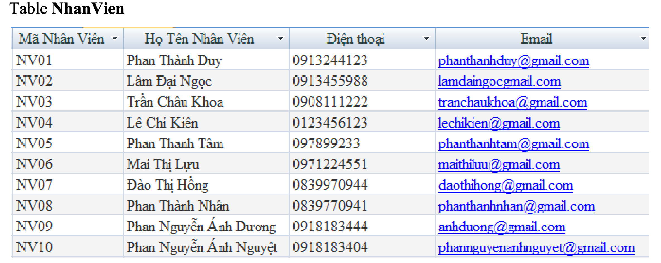

create table Nhanvien(

MaNV char(4) primary key,

HotenNV varchar2(40) not null,

Dienthoai varchar2(10) not null,

Email varchar2(30)

);

INSERT INTO Nhanvien VALUES ('NV01', 'Phan Thanh Duy', '0913244123', 'phanthanhduy@gmail.com');

INSERT INTO Nhanvien VALUES ('NV02', 'Lam Dai Ngoc', '0913455988', 'lamdaingoc@gmail.com');

INSERT INTO Nhanvien VALUES ('NV03', 'Tran Chau Khoa', '0908111222', 'tranchaukhoa@gmail.com');

INSERT INTO Nhanvien VALUES ('NV04', 'Le Chi Kien', '0123456123', 'lechikien@gmail.com');

INSERT INTO Nhanvien VALUES ('NV05', 'Phan Thanh Tam', '097899233', 'phanthanhtam@gmail.com');

INSERT INTO Nhanvien VALUES ('NV06', 'Mai Thi Luu', '0971224551', 'maithiluu@gmail.com');

INSERT INTO Nhanvien VALUES ('NV07', 'Dao Thi Hong', '0839970944', 'daothihong@gmail.com');

INSERT INTO Nhanvien VALUES ('NV08', 'Phan Thanh Nhan', '0839770941', 'phanthanhnhan@gmail.com');

INSERT INTO Nhanvien VALUES ('NV09', 'Phan Nguyen Anh Duong', '0918183444', 'anhduong@gmail.com');

INSERT INTO Nhanvien VALUES ('NV10', 'Phan Nguyen Anh Nguyet', '0918183404', 'phannguyenanhnguyet@gmail.com');

**Tao Bang Khach Hang tuong tu bang Nhan vien (tự nhập 10 khách hàng từ KH01..KH10)**

**Khachhang(MaKH, TenKH, Dienthoai, Email)**

create table KhachHang(

MaKH char(4) primary key,

HotenKH varchar2(40) not null,

Dienthoai varchar2(10) not null,

Email varchar2(30)

);

INSERT INTO KhachHang (ma, Ten, SDT, EMAIL) VALUES ('KH01', 'Nguyễn Văn A', '1234567890', 'nguyenvana@gmail.com');

INSERT INTO KhachHang (ma, Ten, SDT, EMAIL) VALUES ('KH02', 'Trần Thị B', '0987654321', 'tranthib@gmail.com');

INSERT INTO KhachHang VALUES ('KH03', 'Lê Hoàng C', '0912345678', 'lehoangc@gmail.com');

INSERT INTO KhachHang VALUES ('KH04', 'Phạm Thanh D', '0876543210', 'phamthanhd@gmail.com');

INSERT INTO KhachHang VALUES ('KH05', 'Ngô Quang E', '0123456789', 'ngoquange@gmail.com');

INSERT INTO KhachHang VALUES ('KH06', 'Vũ Minh F', '0956789012', 'vuminhf@gmail.com');

INSERT INTO KhachHang  VALUES ('KH07', 'Đặng Mai G', '0890123456', 'dangmaig@gmail.com');

INSERT INTO KhachHang VALUES ('KH08', 'Bùi Thu H', '0932109876', 'buithuh@gmail.com');

INSERT INTO KhachHang  VALUES ('KH09', 'Hoàng Nam I', '0865432109', 'hoangnami@gmail.com');

INSERT INTO KhachHang VALUES ('KH10', 'Trương Linh J', '0943210987', '[truonglinhj@gmail.com](mailto:truonglinhj@gmail.com)');

**Bảng Phieuxuat(SoPX, *MaNV*, *MaKH*, Ngayban)**

**SoPX la khoa chinh**

**MaNV, MAKH la khoa ngoai.**

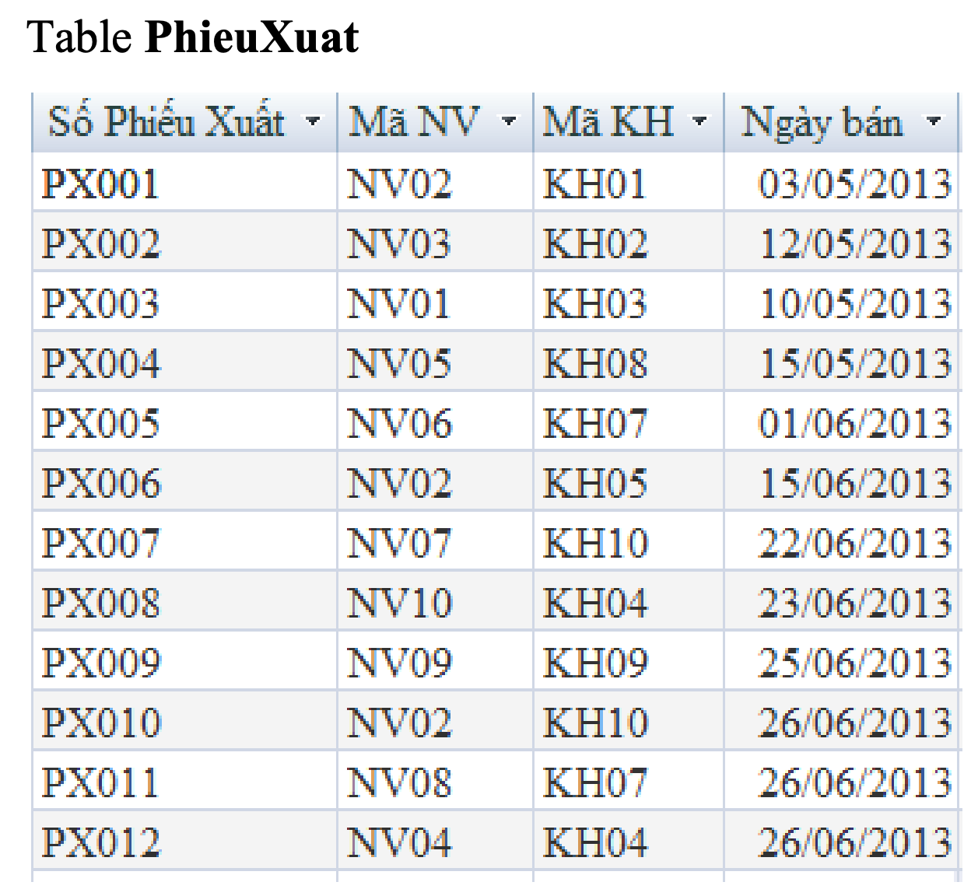

CREATE TABLE Phieuxuat(

SoPX char(5) PRIMARY KEY,

MaNV char(4),

MaKH char(4),

Ngayban date,

FOREIGN KEY (MaNV) REFERENCES Nhanvien(MaNV),

FOREIGN KEY (MaKH) REFERENCES KhachHang(MaKH)

);

INSERT INTO Phieuxuat VALUES ('PX001', 'NV02', 'KH01', '05/03/2013');

INSERT INTO Phieuxuat VALUES ('PX002', 'NV03', 'KH02', '05/12/2013');

INSERT INTO Phieuxuat VALUES ('PX003', 'NV01', 'KH03', '05/10/2013');

INSERT INTO Phieuxuat VALUES ('PX004', 'NV05', 'KH08', '05/15/2013');

INSERT INTO Phieuxuat VALUES ('PX005', 'NV06', 'KH07', '06/01/2013');

INSERT INTO Phieuxuat VALUES ('PX006', 'NV02', 'KH05', '06/15/2013');

INSERT INTO Phieuxuat VALUES ('PX007', 'NV07', 'KH10', '06/22/2013');

INSERT INTO Phieuxuat VALUES ('PX008', 'NV09', 'KH09', '06/23/2013');

INSERT INTO Phieuxuat VALUES ('PX009', 'NV02', 'KH10', '06/25/2013');

INSERT INTO Phieuxuat VALUES ('PX010', 'NV08', 'KH07', '06/26/2013');

INSERT INTO Phieuxuat VALUES ('PX011', 'NV04', 'KH04', '06/26/2013');

INSERT INTO Phieuxuat VALUES ('PX012', 'NV02', 'KH09', '06/26/2013');

**Bảng ChitietPX(*SoPX*, *MaSP*, Soluong, Giaban)**

**SoPX va MaSP la khoa ngoai**

**Khoa chinh: (SoPX, MASP)**

**Soluong va giaban >0**

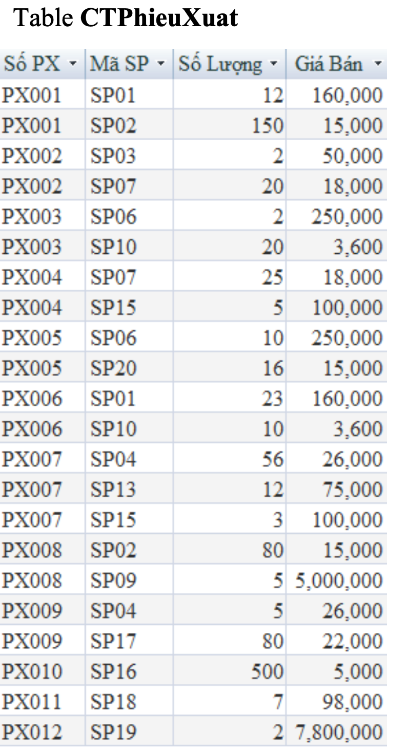

CREATE TABLE ChitietPX(

SoPX CHAR(5),

MaSP CHAR(4),

Soluong INT CHECK (Soluong > 0),

Giaban FLOAT CHECK (Giaban > 0),

PRIMARY KEY (SoPX, MaSP),

FOREIGN KEY (SoPX) REFERENCES Phieuxuat(SoPX),

FOREIGN KEY (MaSP) REFERENCES SANPHAM(MaSP)

);

INSERT INTO ChitietPX VALUES ('PX001', 'SP01', 12, 160000);

INSERT INTO ChitietPX VALUES ('PX001', 'SP02', 150, 15000);

INSERT INTO ChitietPX VALUES ('PX002', 'SP03', 2, 50000);

INSERT INTO ChitietPX VALUES ('PX002', 'SP07', 20, 18000);

INSERT INTO ChitietPX VALUES ('PX003', 'SP06', 2, 50000);

INSERT INTO ChitietPX VALUES ('PX003', 'SP10', 20, 3600);

INSERT INTO ChitietPX VALUES ('PX004', 'SP07', 25, 18000);

INSERT INTO ChitietPX VALUES ('PX004', 'SP15', 5, 100000);

INSERT INTO ChitietPX VALUES ('PX005', 'SP06', 10, 250000);

INSERT INTO ChitietPX VALUES ('PX005', 'SP20', 16, 15000);

INSERT INTO ChitietPX VALUES ('PX006', 'SP01', 23, 160000);

INSERT INTO ChitietPX VALUES ('PX006', 'SP10', 10, 3600);

INSERT INTO ChitietPX VALUES ('PX007', 'SP04', 56, 26000);

INSERT INTO ChitietPX VALUES ('PX007', 'SP13', 12, 75000);

INSERT INTO ChitietPX VALUES ('PX007', 'SP15', 3, 100000);

INSERT INTO ChitietPX VALUES ('PX008', 'SP02', 80, 15000);

INSERT INTO ChitietPX VALUES ('PX008', 'SP09', 5, 5000000);

INSERT INTO ChitietPX VALUES ('PX009', 'SP04', 5, 26000);

INSERT INTO ChitietPX VALUES ('PX009', 'SP17', 80, 22000);

INSERT INTO ChitietPX VALUES ('PX010', 'SP16', 500, 5000);

INSERT INTO ChitietPX VALUES ('PX011', 'SP18', 7, 98000);

INSERT INTO ChitietPX VALUES ('PX012', 'SP19', 500, 5000);

**--Thay giá bán của dòng (PX008, SP09) thành 5100000**

UPDATE  ChitietPX SET Giaban = 5100000 WHERE SoPX ='PX008' AND MaSP ='SP09';

**--Xóa dòng (PX004, SP07)**

DELETE FROM ChitietPX WHERE SoPX ='PX004' AND MaSP ='SP07';

**--Thay cấu trúc cột giaban thanh Numeric(12,1)**

ALTER TABLE ChitietPX MODIFY Giaban NUMERIC(12,1);